**Project Design Phase**

**-**

**I**

**I**

**Technology Stack (Architecture & Stack)**

Date

17

th

October

2022

Team ID

PNT2022TMID

52762

Project Name

Gas Leakage monitoring & Alerting system for Industries

Maxim

um marks

4

m

arks

**Technical Architecture**

**:**

**DEVELOPMENT OF TASK ANALYSIS:**

**Hardware Requirements**

1)

Arduino UNO Microcontroller

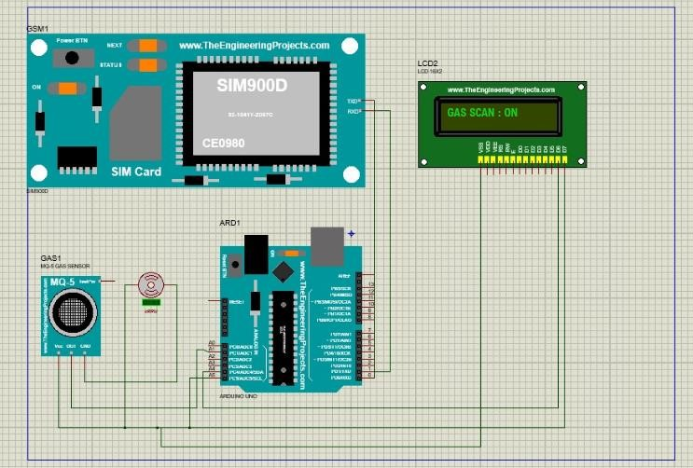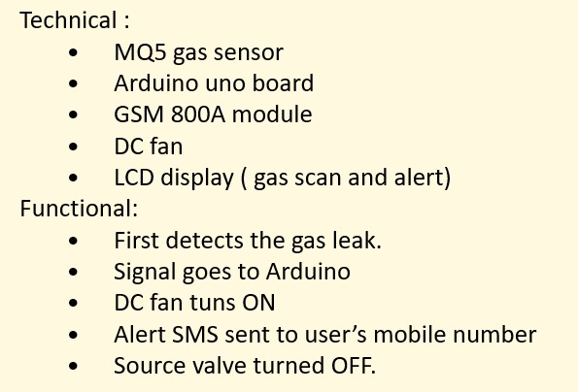

|  |
| --- |
| 1. Green LED 1, Red LED 3 2. 9V Power supply (230V TO 9V STEPDOWN TRANSFORMER) 3. MQ5 Gas sensor 4. GSM 800 Module 5. GSM Sim 6. Connecting wires 7. Project base   **Software Requirements**   1. Arduino IDE 2. Language C++   **WORKING:**  **Step 1**: A signal from the microcontroller will go to the display and show gas leakage message there.  **Step 2**: Simultaneously automatically turns on the DC fan to ventilate the leaked gas, and the source solenoid valve will be turns off  **Step 3**: Signal from microcontroller activates the GSM module and sends an alert SMS “ALERT GAS LEAKING” to the user’s mobile number. |